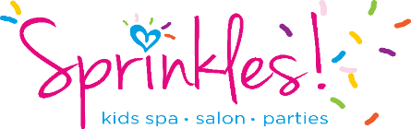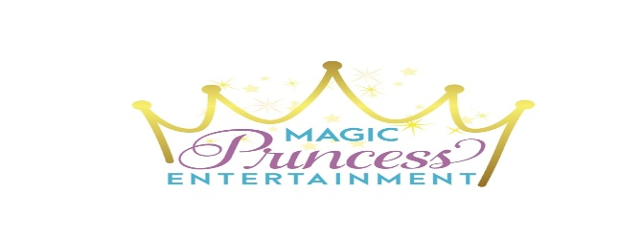
SUMMER DAY CAMPS
Come with a friend or make new ones!
PAINT WITH US!
Tuesday, July 9 10:30am-1:30pm $40 per child
Color Spray “Painted” Hair, Glitter Hair, Scented Hair, Deluxe Face Gems and Glitter Tattoos. Fancy Canvas Painting Activity to take home. Games & Ring Pops.
UNICORNS, RAINBOWS & SPRINKLES
Thursday, July 25 10:30am-1:30pm $45 per child
Rainbow Hair Color, Keepsake Unicorn Horn Headband, Glitter Hair, Scented Hair, Rainbow Makeup with Face Gems, Rainbow Polish Glitter Nails with Fashion Rings, Each Child Receives their very own Deluxe Unicorn Stuff Animal! Unicorn Cotton Candy, Pink Lemonade & Ice Cream with extra Sprinkles!
PRINCESS CINDERELLA, TIARAS & TEA PARTY
Friday, July 26 10:30am-1:30pm $40 per child
Jewelry Making, Magic Mirror Craft, Each Child Receives Keepsake Tiaras, Princess Makeovers and Tea Party/Pink Lemonade. Dress Up & Royal Coronation. Princess Cinderella will make a Surprise Appearance for photos, games & more!
SPRINKLES TALENT SHOW
Thursday, August 1 10:30am-1:30pm $40 per kid
Lights, Camera, Talent! Enjoy Fun Mini Hair Style Up-Do’s, Shimmery Makeup with Face Gems, Craft Activity, Let your confidence soar at Sprinkles Talent Show. Get ready to SHINE! This is for FUN and will not be judged.
Parents are welcome to can come at 1:00pm to watch!
SLIME TIME
Friday, August 2 10:30am-1:30pm $40 per child
Slime Pedicures with Bath Bomb Foot Soak, Slime Foot Wash, Scented Lotion, Polished Toes, Toe Rings, Make & Take Your Own Slime Creation! Color Spray Hair, Glitter Hair and Scented Hair.
SPRINKLES COOKING WITH KIDS
Thursday, August 8 10:30am-1:30pm $40 per child
Kids will enjoy doing it all on their own! Learn the confidence to help out in the kitchen. Delicious Cheesy Quesadillas, Cut & Peel Veggies, Magical Unicorn Dessert and Pink Lemonade. Polished Nails with Rings, Decorate Kid Chef Hats and Play Fun “Cooking” Games!
IT’S TIME TO BE KIND
Friday, August 9 10:30am-1:30pm $35 per child
Polished Nails with Fashion Rings, Let’s learn about being kind, we will lead a discussion on ideas on how to Sprinkle Kindness Everywhere, Glitter Tattoos, Kindness Games, Paint & Create Kindness Rocks & Etiquette Lesson.
ELSA DISNEY SPA DAY
Thursday, August 15 10:30am-1:30pm $40 per child
Come dressed in your favorite Disney Character and enjoy a day of pampering and play! Manicures with Bath Bomb Hand Soak, Scented Lotion, Polished Nails and Fashion Rings. Shimmery Makeup with Face Gems, Princess Craft, Cookies & Pink Lemonade. Snowball Fight Game, Freeze Dance & Other Games. Special Princess Appearance from Elsa!
SWEET SPA DAY
Friday, August 16 10:30am-1:30pm $40 per kid
Come dressed in your favorite jammies! Relax with Manicures and Fun Facials with Cucumbers. Make and Take your own Bubble Bath and Pillow Case! Movie, Pink Lemonade and Popcorn Provided!

FASHION DESIGN
Thursday, August 22 10:30am-1:30pm $40 per kid
Learn about what it takes to be a Fashion Designer. Let’s get Creative; Sketch and Design Fashion Creations and Design your own Flip Flops! Photo Shoot of all fashion designers to show off their creations. Fashion Show on Runway. Children will need to bring old clothing to be cut/reused into new designs. Kids will be guided during use of scissors, glue & light sewing.
LET’S GO ‘GLAM’PING
Friday, August 23 10:30am-1:30pm $40 per kid
Diggin’ in the Dirt Pedicures with Creepy Crawler Bugs, Bath Bomb Foot Soak, Scented SLIME foot wash & Toe Rings, Bear “Poop” Game, Don’t Drop the Fire Flame Game, Decorate & Keep Camp Sprinkles T-Shirts, “Drive-in” Movie, Popcorn and Decorate Cupcakes with SMORE Toppings.

Camps are best suited for ages 4+ and must be potty trained. All camps are drop off. Bring packed lunch (unless food is provided) with drinks (please no nut products). Please alert us of any allergies.
Space is Limited. Campers must be registered and prepaid before camp. All camps include Dress Up and Runway Stage time. We have the right to cancel any event due to low enrollment, in which you would get a full refund.

Contact us at SprinklesKidsParties@Gmail.com with your name, your child’s name, child’s age and your phone number. We will add you to the registration list and then someone will call you to get payment.

Sprinkles, 1603 Route 9, Clifton Park, NY 12065
518-977-4024
www.SprinklesKidsParties.com

